 | OSP Social Media Resource  Introduction

Welcome to the Ontario Skills Passport (OSP) Social Media Resource!
Social media refers to different types of online communication such as Facebook, Twitter, Instagram and blogs.
Let’s Get Started!
There are four modules in this resource. You can do the modules in the order 1 to 4, or you can mix them up.
Each module covers an important aspect of social media that will help you use it safely and effectively to showcase your Essential Skills and work habits and get noticed when you are looking for a great:
- post-secondary program
- apprenticeship
- volunteer position
- job or internship
.
Here are the four module titles:
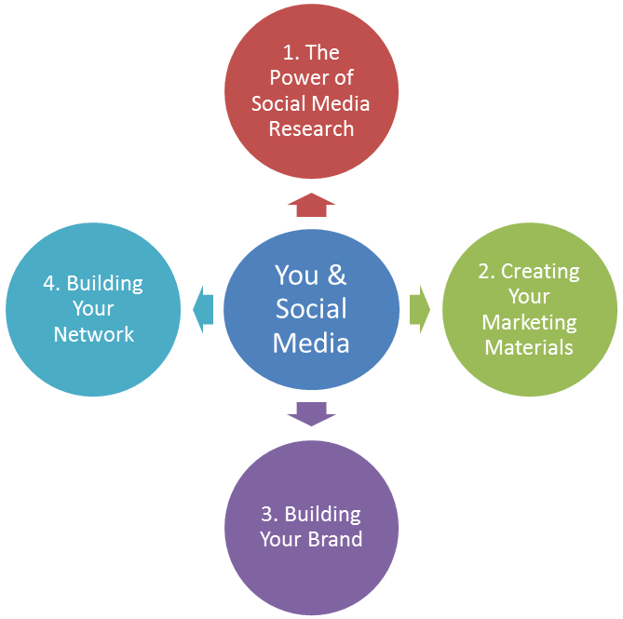

How to use this OSP Social Media Resource
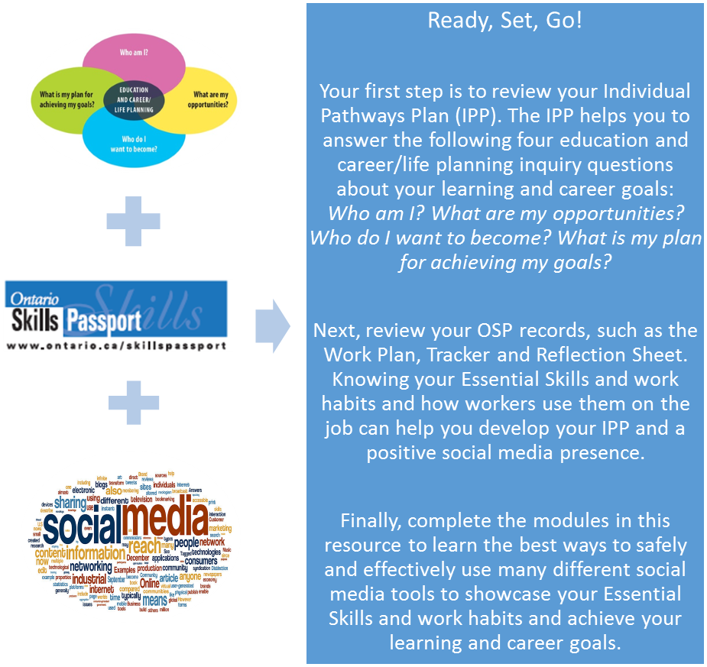
Use the OSP tools and resources to assess, build, document and track your Essential Skills and work habits in classroom and experiential learning, in the workplace and in the community. Your OSP records provide valuable evidence of your skills – skills that are transferable to further education, training, the workplace and everyday life.

Image credit: Sofiaperesoa, Social Media, Creative Commons Attribution.
Introduction to Some Popular Social Media Sites
The following is a basic introduction to some of the most popular social media networks. Some networks are designed to be social and some professional; some share detailed content and others just images. Once you know what each network is designed to do, you can better decide if using it is a good place to profile your skills and experience.
Facebook    www.facebook.com | - By the beginning of 2013, there were over one billion people on Facebook and one in every two Canadians has a Facebook account.  - You can build a huge network of Facebook friends over time. As with any social network, the content you share, like, and comment on, is a direct reflection of your character.  - In addition to sharing and creating your own content you can also join or create pages and groups about any topic you want. A lot of great companies also have their own Facebook pages.  - If you get an interview with a company, always check to see if they have a Facebook page. You may learn something new about the company which you can mention in your interview. Recruiters appreciate applicants who have done their research.
YouTube    www.youtube.com | - According to YouTube more than 1 billion people visit the site every month to watch and share originally-created videos and over four hours of video is uploaded to YouTube every 60 seconds.  - YouTube is also the Internet’s 2nd largest search engine. When someone wants to learn how to do something, chances are they’ll find dozens of how-to videos created by people just like you on YouTube.  - YouTube is good for sharing your knowledge about a particular subject or demonstrating something you know how to do very well.  - You don’t need any fancy equipment or editing software to create a video. Simply use a cellphone camera and edit your video in YouTube directly.  - You can adjust the privacy settings on the videos you share so you can control who is able to see them.

Blogs    http://wordpress.com/    http://blogger.com | - A blog is a Website that shares digital content including articles, videos, pictures and graphics, usually about a particular topic or theme.  - The content can be produced by single or multiple authors and is generally displayed in chronological order.  - Each blog will have its own unique Web address (URL).  - Blogs can be private or public. People can subscribe to or comment on your updates.  - You don’t need to be a Website designer to create a blog. There are several Websites that will help you easily create one for free including WordPress and Blogger.  - Running a successful blog takes a lot of time and effort. It must be updated regularly and frequently with fresh content. If you don’t think you’ll have the time consider starting one with your friends and sharing the work.
Twitter    www.twitter.com | - Twitter can be considered a “microblog”  - Unlike a regular blog, where a post can be as long as you want it to be, a Twitter post (also called a tweet) is limited to 140 characters.  - Tweets often contain links to photos and other Websites  - Twitter is arguably the fastest way to share information on the Internet because the posts are so short.  - Most Twitter accounts are public and do not require the permission of the account owner to follow them.  - To use Twitter effectively, it is important to find and share updates that your followers may care about. Some people create Twitter accounts dedicated to a particular topic while others share their lives and/or their interests. People often share job postings and industry events too.

Tumblr    www.tumblr.com | - If Twitter and Blogger had a baby, it would be called Tumblr.  - This microblogging network, is an easy way to post text, pictures, songs, quotes, opinions, video clips or pretty much anything you think is inspiring or worth sharing.  - Tumblr looks like a blog, but the posts tend to be much shorter than traditional blog articles (but can be more than 140 characters).  - You can follow the content of other users and re-post (re-blog) their content onto your own Tumblr feed, which is also similar to the Twitter experience.  - Tumblr is an easy way to express what you’re passionate about and also find and follow people who share the same interests as you.
LinkedIn    www.linkedin.com | - Some people refer to LinkedIn as the Facebook for career-focused professionals. LinkedIn also has a special section devoted to helping students make informed choices about post-secondary options and how to make the transition from study to employment.  - While the networks have some similarities, such as profiles, pictures, company pages and status updates; the social cultures are completely different.  - Professionalism is a must on LinkedIn. Everything shared on LinkedIn should be focused on your skills and knowledge, the industry you work in (or want to work in) or relevant business news and trends.  - LinkedIn is a great Website to look for jobs and network with people in the industry you want to work in. You may find more use for it as you gain more experience in the work world. Must be 14+ years of age to create a profile.

Photosites  Instagram    www.instagram.com  Flickr    www.flickr.com |  | - Instagram and Flickr are great for sharing photos of just about anything.  - Flickr provides a more organized approach to photo sharing because you can organize your photos into different sets and albums where people can comment on your photos  - Flickr is the type of network where you would plan to upload and organize a number of pictures at once (with a traditional camera or cell phone camera) rather than sharing one picture you took with a camera in the moment.  - Instagram is much more social. Instagram is primarily accessed through a smartphone app and it works together with the phone’s camera. The app features special photo filters to help you get really creative with your shots. Instagram has an "in the moment "sharing culture because most of the content shared are cell phone camera shots.  - In addition to photos you can also share graphics on both networks.
Pinterest    www.pinterest.com | - Pinterest is a picture-based bookmarking tool for collecting, organizing and saving content you find on the Internet.  - Pinterest looks and works like a bulletin board and can be an excellent tool when you are doing research for a project at school, on a career you are interested in, a topic you are passionate about, or just for fun.  - Instead of saving (bookmarking) an important text link, you save the picture or video from the Website to a board that you have created in Pinterest. This is called pinning.  - You can organize what you find by creating and labelling your pinboards and pins. You can share what you’ve found directly to Facebook and Twitter, follow other people’s pinboards and repin what they have found to your own boards.

SlideShare    www.slideshare.com | - Have you ever created a PowerPoint presentation before? You can share your presentation on a Website called SlideShare.  - SlideShare hosts hundreds of thousands of PowerPoint presentations on just about every topic imaginable and is a great place to do research for a project, on current trends in a particular industry, or on a company you are interested in working for.  - If there is a topic, industry or issue you know a lot about, consider sharing your expertise by posting your presentation to SlideShare.  - People create and share presentations about themselves and their experience as a visual add-on to their résumé. It’s a great way to introduce yourself to someone you have never met.  - You can also create a presentation about a company you want to work for to show them that you did your research and you are passionate about working for them.  - Like other social network sites, you can follow other members, like, save, share and comment on their presentations too.

 | Social Media Quiz | 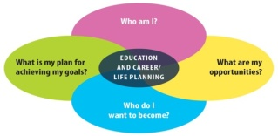
Your Name: _______________________________________
Date: __________________________
Match the logo to the correct social media site.
A |  | F |  | 1 | Facebook | 6 | Pinterest
B |  | G |  | 2 | Twitter | 7 | WordPress
C |  | H |  | 3 | YouTube | 8 | Tumblr
D |  | I |  | 4 | Flickr | 9 | RSS
E |  | J |  | 5 | Google+ | 10 | SlideShare

Answer Key: A-7, B-1, C-10, D-6, E-4, F-9, G-3, H-5, I-2, J-8
Cyber Safety
Social media networks are great tools that allow you to access and share terrific information. But like all tools, you need to know how to use them safely. Here are some great tips for keeping safe online from the Kids Help Phone page.
 | Keep your passwords private, even from your friends. If something unsafe happens, or if you think your password might be in someone else’s hands, change it. |  | When you’re asked for personal information, like a credit card number, look at the bottom right corner of the screen for a little padlock symbol. This means the connection is secure and no one else can see what you’re doing.
 | Don’t make it easy for strangers to track you down. Keep your personal information to yourself. Personal information includes your name, the names of friends or family, your address, phone numbers, and the name of your school. |  | Don’t forward cruel messages to others, or participate in online polls for rating people’s appearance.
 | Don’t accept friend invites from strangers. |  | Trust your gut. If you don’t recognize the name of a sender, don’t open or answer the message.
 | Make sure that only friends can see your profile info. You can make changes to who can access your account under “personal settings” or “settings.” |  | Think about how you can be safe if you meet someone online in-person. Be sure to meet in a public place, bring a friend, and make sure you have a cell phone with you.

Don’t post pictures of yourself or others without permission. Think of your photo as another kind of personal information just like your address or phone number. Not sure what to post? Check with a parent or teacher before sharing personal pictures.

Think you know how to be safe online?
Take the quiz on the next page and find out.
 |  |  |  | Internet Safety Quiz
Your Name: _______________________________________
Date: __________________________
Below are ten questions about safety on the Internet. If you are using the Internet for research, for social activities, communication, or just for fun, it’s important that you know this information. Match the questions in the first column with the correct answers in the second. Check your answers below.
A | When you log on to the Internet, it is a good idea to use a nickname. | 1 | No. It is not a good idea to give out your birth date on the Internet. Most Websites request it but you don’t have to give it. Protect yourself from identify theft.
B | It is OK to email your credit card number if the online store you shopped at asks for it again. | 2 | No. While posting pictures on the Internet is a great way to share photos you must have the permission of everyone in the picture.
C | It is all right to give your name, address and birth date when registering to use a Website online. | 3 | No. Just because a site has a privacy policy doesn’t mean they don’t reserve permission to share your information. Read the policy carefully and ask for help if you don’t understand what it means.
D | It is OK to give out your Social Insurance Number (SIN) when you are online. Everyone who uses the Internet has access to it anyway. | 4 | No. If you receive an e-mail from a store you recently shopped at online asking for your credit card number again, ignore it. Secure Websites do not give the store your complete credit card as a way to protect you.
E | Blogging is a good way to voice your opinion and you don't have to use your real name. | 5 | No. Never assume that everyone has access to personal identifying information. While it is possible to obtain this information, very few people really know how to access it. Protect your SIN and other identifying pieces of information from prying eyes.
F | You don’t need permission to post pictures of yourself volunteering with a group of kids at camp on the Internet; it’s your volunteer job. | 6 | No. The Internet is an open forum for anyone and everyone. Evaluate carefully ALL information on Websites, personal or public. Be honest in the information you share as well.
G | Information on the Internet can always be trusted to be factual. It wouldn’t be online if it wasn’t true. | 7 | No. Employers, volunteer organizations and post-secondary institutions may all do an online search for information about you when considering your application. Exaggerating may get your application disqualified.
H | If a website has a privacy policy it means they cannot share your information. | 8 | Yes. It is always a good idea to use a nickname when you log on to the Internet. Don't make it easy for identity thieves to find you.
I | It is okay to exaggerate your skills in your blog; everyone does it so people expect it. | 9 | No. Using one password for everything is risky. If people figure out your password for one thing they could use it to gain access to your private email and even your money.
J | It’s efficient to use the same password for all your online activity (e.g. blog, Facebook, Twitter). | 10 | No. Blogging is a good way for people to express their opinions and vent. However, never assume that your identity is a secret. There are many ways to track those that blog and to find out their true identities.
Answer Key: A-8, B-4, C-1, D-5, E-10, F-2, G-6, H-3, I-7, J-9
 | Social Media Reflection | 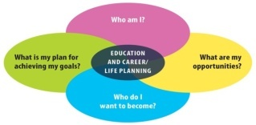
- Name one social media site that you have not used before that you are now excited about using. Explain why.
- Name two things you would use a company blog for.
a)

b)

- Name one thing you could use Twitter for.
- Find a blog on a topic you are interested in. Write the name of the blog and the URL below and provide a brief summary of the blog content.
a) Blog name:

b) URL (Web address):

c) What the blog is about:

- For each of the following tasks, identify which social media you would use and briefly explain why. Sometimes there is more than one correct answer, so the reason why you would choose a particular network is important. Discuss your reasons with the teacher.
Task | Which Social Media? | Why?
- Share pictures of your vacation
- Learn how to play the ukulele
- Learn what countries a company has offices in
- Provide a short link to an newspaper article you like
- Tell a friend if you are going to a concert
- Share your PowerPoint on water conservation
- Connect with someone you met at a fundraiser
- Create an online portfolio
- Share a video of a class debate

Answer Key (Question 5)
As each of the social media can be used for different purposes, there are multiple possible answers for many of the examples. Some of the more likely answers are shown below. The important thing is that the students are able to provide a rationale for each of the choices they make.
Task | Which Social Media?
- Share pictures of your vacation | Flickr, Instagram, Facebook
- Learn how to play the ukulele | YouTube
- Learn what countries a company has offices in | LinkedIn, WordPress, Company’s Website
- Provide a short link to an newspaper article you like | Twitter. WordPress, Blogger
- Tell a friend if you are going to a concert | Facebook
- Share your PowerPoint on water conservation | SlideShare, LinkedIn
- Connect with someone you met at a fundraiser | Facebook, Twitter
- Create an online portfolio | WordPress, SlideShare, Pinterest, Tumblr
- Share a video of a class debate | YouTube. Tumblr

Work Smart: Stay Safe
Social media is a great tool to expand your opportunities for post-secondary education, volunteer work and employment. But like any tool it is important to take precautions to stay safe while you are using it. Before beginning these modules:

- Make sure your parents know what websites you are using before you start any social media networking.
- Check with your teacher or guidance counsellor for any additional school board policies that may apply in your area.
The Kids Help Phone website has some great online safety tips.

Ready to learn more about using social media to showcase your Essential Skills and work habits to achieve your goals?
Go to OSP Social Media Resource Module 1: The Power of Social Media Research.

